**ENGINEER**

**Table of Contents**



* [#1 Aerospace Engineering](https://engineercalcs.com/types-of-engineering/#1_Aerospace_Engineering)
* [#2 Agricultural Engineering](https://engineercalcs.com/types-of-engineering/#2_Agricultural_Engineering)
* [#3 Audio Engineering](https://engineercalcs.com/types-of-engineering/#3_Audio_Engineering)
* [#4 Bioengineering](https://engineercalcs.com/types-of-engineering/#4_Bioengineering)
* [#5 Chemical Engineering](https://engineercalcs.com/types-of-engineering/#5_Chemical_Engineering)
* [#6 Civil Engineering](https://engineercalcs.com/types-of-engineering/#6_Civil_Engineering)
* [#7 Computer Engineering](https://engineercalcs.com/types-of-engineering/#7_Computer_Engineering)

#8 Electrical Engineering

* [#9 Environmental Engineering](https://engineercalcs.com/types-of-engineering/#9_Environmental_Engineering)
* [#10 Geotechnical Engineering](https://engineercalcs.com/types-of-engineering/#10_Geotechnical_Engineering)
* [#11 Industrial Engineering](https://engineercalcs.com/types-of-engineering/#11_Industrial_Engineering)
* [#12 Materials Engineering](https://engineercalcs.com/types-of-engineering/#12_Materials_Engineering)
* [#13 Mechanical Engineering](https://engineercalcs.com/types-of-engineering/#13_Mechanical_Engineering)
* [#14 Ocean / Marine Engineering](https://engineercalcs.com/types-of-engineering/#14_Ocean_Marine_Engineering)
* [#15 Mining Engineering](https://engineercalcs.com/types-of-engineering/#15_Mining_Engineering)

## . Chemical Engineer

Chemical engineers apply key principles of mathematics, biology, chemistry, and physics to create and manufacture various products. Whereas some professionals in the field work at refineries to transform crude oil into products such as asphalt, heating oil, gasoline, and lubricating oil, others work at companies that convert other raw materials, such as beeswax, into candles, home and body creams, and furniture polish.

Although some job duties for chemical engineers, such as estimating production costs, are uniform across the field, others can vary widely depending on the company. Common daily duties may include:

* Conducting tests and monitoring the performance of various processes
* Troubleshooting problems that arise in the manufacturing process
* Developing methodologies for separating components in gasses and liquids
* Conducting research designed to improve manufa cturing processes

## chemical engineering discovering new materials

**8 Electrical Engineering**

As a kid, I 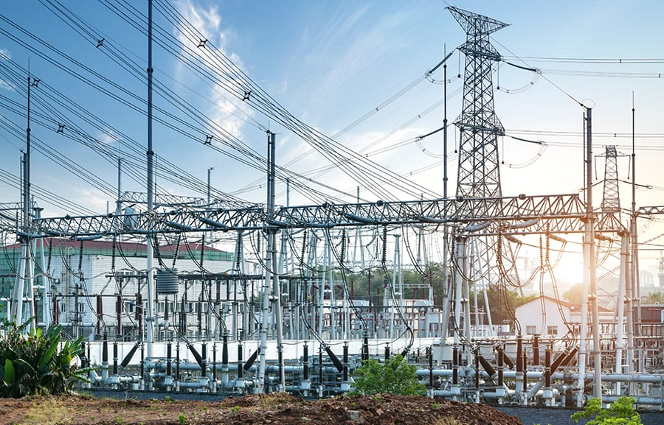was captivated by Nikola Tesla and his electrifying experiments. Nowadays, it’s hard to imagine life without electricity – no lights, smartphones, internet, refrigerated food, or power. Sounds like a nightmare, right?

[**Electrical engineering has come a long way and now thrives**](https://engineercalcs.com/will-automation-destroy-future-electrical-engineering-jobs/) with these subfields:

* **Communication:** Designing systems and equipment to transmit data.
* **Controls:** Making systems efficient and predictable.
* **Electronics:** Designing and developing electronic components.
* **Power:** Generating, transmitting, and distributing power.

### **Cool jobs:**

* **Power grid:** Managing the U.S. power grid, the largest machine on Earth, and a complex yet outdated electrical system.
* **Signal processing:** Optimizing signals for various use cases.
* **Renewable energy sources:** Enhancing clean energy tech.
* **Industrial automation:** Aiding the transition from human labor to machine automation.
* **Electronics:** Designing electronics for different purposes.

### **Amazing accomplishments:**

* **Satellite communication**: Satellites orbiting 22,000 miles above us at 7,000 mph.
* **U.S. Power grid:** The Earth’s largest machine.
* **Microprocessors:** The hardware making computers possible.
* **Electric motors/generators:** Powering electric devices and providing running water.
* **Transformers:** Essential for power grid operation.

### **Future pursuits:**

* **Improved power grid:** Updating and repairing aging power grids.
* **Advanced robotics:** Boosting industry efficiency without added human labor.
* **Nanotechnology:** Tackling problems at a micro-level.
* **Smart grids:** Using smart devices with power grids to save costs and improve energy management.
* **Bulk energy storage:** Enhancing battery energy storage.
* **Electric cars and planes:** Swapping fossil fuels for batteries in transportation.
* **Engine efficiency:** Boosting engine efficiency.
* **Renewable energy:** Discovering and designing new renewable energy sources.

**9 Environmental Engineering** 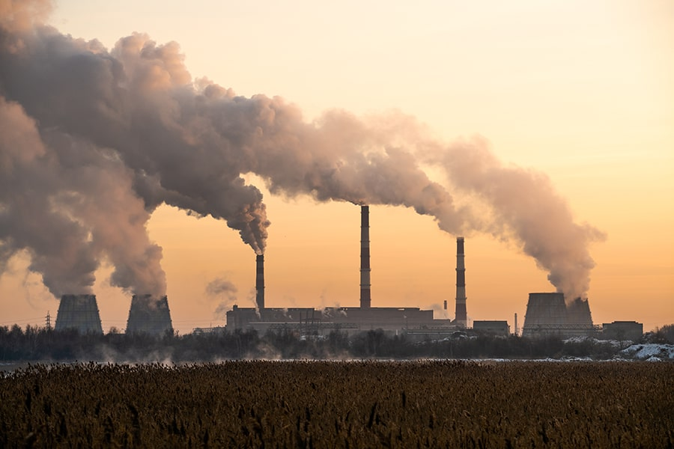

It’s mind-boggling how we, as a supposedly intelligent species, struggle to protect our planet. Human greed often leads to disastrous decisions that harm our environment.

Sadly, I often hear people badmouthing environmental engineers, accusing them of stalling and complicating engineering projects. But engineers need boundaries to prevent long-term damage. Even well-intentioned projects can backfire without regulation.

Fear not, environmental engineers are here to save the day! They prevent and clean up messes, using their skills to solve problems like waste disposal, public health, recycling, and pollution control.

### **Cool jobs:**

* **Air quality control:** Preserving air quality as populations grow.
* **Water/Wastewater:** Designing dams, diversion structures, and sewer lines.
* **Environmental remediation:** Keeping project sites clean during and after construction.

### **Amazing accomplishments:**

* **Clean water supply:** Providing fresh water to millions worldwide.
* **Pollution management:** Ensuring clean air and water in cities.
* **Waste management:** Scaling waste management systems.

### **Future pursuits:**

* **Developing countries:** Extending environmental protection practices to developing countries.
* **Water treatment:** Designing more efficient and affordable water treatment.
* **Pollution control:** Adopting global pollution and waste management protocols.
* **Sustainable communities:** Building sustainable, self-sufficient communities.
* **Renewable energy:** Managing the global transition to renewable energy.

**10 Geotechnical Engineering** 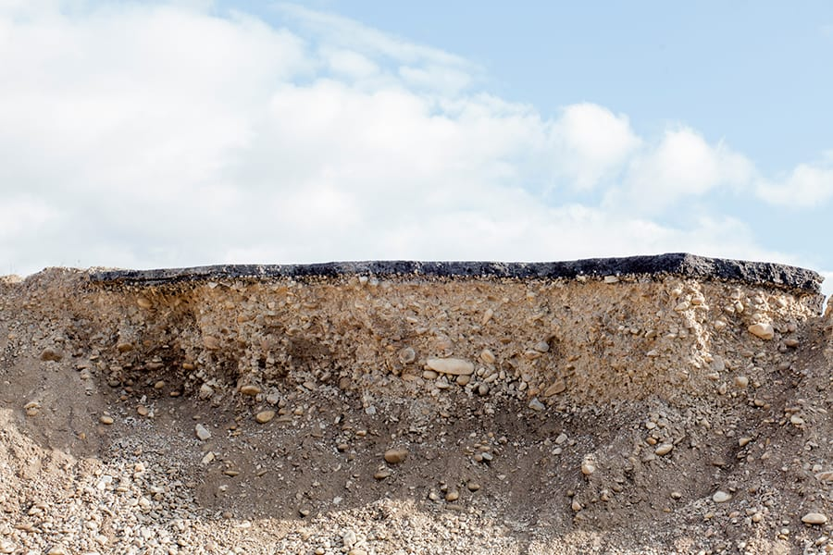

Geotechnical engineers investigate soil and rock effects on engineering projects, sharing insights with engineers who need the data for their designs.

For instance, structural engineers need soil data to build secure foundations, and I require soil information to design safe ground grids due to varying resistivities.

In a nutshell, geotechnical engineers play a crucial role in shaping numerous engineering designs.

### **Cool jobs:**

* **Concrete and asphalt testing:** Testing materials for all types of engineering projects.
* **Construction supervision:** Overseeing projects and inspecting subsurface conditions.
* **Soil inspection:** Examining soil in exotic locations for innovative designs.

### **Amazing accomplishments:**

* **Bridges:** Massive, lengthy bridges defying harsh environments.
* **Skyscrapers:** Towering skyscrapers rising in diverse settings.